**VISVESVARAYA TECHNOLOGICAL UNIVERSITY,**

**BELGAUM**



PROJECT REPORT

on

**“DRIVING SIMULATOR”**

Submitted in partial fulfilment of the requirements for the award of

**BACHELOR OF ENGINEERING**

**IN**

# **TELECOMMUNICATION ENGINEERING**

For the academic year 2020-2021

Submitted by

| **SARUMADHI SHIVAMANI** |  |  | **(1CR16TE027)** |
| --- | --- | --- | --- |
| **BHIM** |  |  | **(1CR17TE008)** |
| **DINESH B K** |  |  | **(1CR17TE009)** |
| **JAYANTH K** |  |  | **(1CR17TE014)** |

Under the guidance of

**Mr. Raveesh Hegde**   **Mr. Mahesh Kumar Jha**

**Asst. Professor Head of Department**

**Dept. Of TCE, CMRIT Dept. Of TCE, CMRIT**



**2020-2021**

**Department Of Telecommunication Engineering**

**CMR INSTITUTE OF TECHNOLOGY, Bangalore - 560 037**

# **ACKNOWLEDGEMENT**

The satisfaction that accompanies the successful completion of any task would be incomplete without mentioning the people whose proper guidance and encouragement has served as a beacon and crowned my efforts with success. We take an opportunity to thank all the distinguished personalities for their enormous and precious support and encouragement throughout the duration of this seminar.

We take this opportunity to express our sincere gratitude and respect to **CMR Institute of Technology, Bangalore** for providing us an opportunity to carry out our project work.

We have great pleasure in expressing our deep sense of gratitude to **Dr. Sanjay Jain,** Principal, CMRIT, Bangalore, for his constant encouragement.

With profound sense of gratitude, we acknowledge the guidance and support extended by **Mr. Mahesh Kumar Jha,** HoD, and Mr. Raveesh Hegde, Asst. Professor, Department of Telecommunication Engineering, CMRIT, Bangalore. Their incessant encouragement and invaluable technical support have been of immense help in realizing this project work. Their guidance gave us the environment to enhance our knowledge, skills and to reach the pinnacle with sheer determination, dedication and hard work.

We also extend our thanks to the faculties of Telecommunication Department who directly or indirectly encouraged us throughout the course of project work.

We also thank our parents and friends for all their moral support they have given us during the completion of this work.



# **CERTIFICATE**

This is to certify the Project work entitled “**Driving simulator**”, carried by the following bonafide students of **CMR Institute of Technology, Bengaluru** in partial fulfillment of the requirements for the award of **Bachelor of Engineering in Telecommunication Engineering** of the V**isvesvaraya Technological University, Belagavi-590018** during the academic year 2020-21. This is certified that all the corrections and suggestions indicated for Internal Assessment have been incorporated in the report deposited in the departmental library. The Project report has been approved as it satisfies the academic requirements prescribed for the said degree.

1. Sarumadhi Shivamani (1CR16TE027)
2. Bhim (1CR17TE008)
3. Dinesh B K (1CR17TE009)
4. Jayanth K (1CR17TE014)

| **----------------------** | **-----------------------** | **-----------------------** |
| --- | --- | --- |
| **Signature of Guide** | **Signature of HoD** | **Signature of Principal** |
| **Mr. Raveesh Hegde** | **Mr.Mahesh Kumar Jha** | **Dr. Sanjay Jain** |
| **Asst. Professor** | **(Prof & HOD)** | **CMRIT** |
| **Dept. of TCE, CMRIT** | **Dept. of TCE, CMRIT** |  |

# **External Viva**

# 

**Name of the Examiner Signature with date**

**1.**

**ABSTRACT**

**(Problem statement in layman terms)**

Driving simulators are very expensive to afford and cannot be bought by an average economic class family or person. This also applies to driving schools that have car driving simulators as a means to teach its customers. Often bought by economically “big” schools investing too much on such products. Talking about cars, they are a liability and cost to maintain vehicles is costly business.

**(The proposed system)**

The main purpose of our project is to lower the cost of driving simulators that are generally expensive. Our project is to build the hardware device that acts as an alternative to traditional simulators. Which in turn will be cheaper and affordable. Can also be used as a primary device in driving schools.

(**Technical details)**

In the proposed device, a raspberry pi camera is used to process the data of video that will be continuously captured. This data will be sent to raspberry pi 3.0 to process and emulate the key presses digitally. Raspberry pi 3.0 will consume less power and also be very efficient regarding video processing. The potentiometer will be used to detect acceleration and brake. The steering wheel prototype will be made out of cardboard. Similarly cardboard will be used to create the brake pedal and acceleration pedal.

**CONTENTS**

Pg. no.

ACKNOWLEDGEMENT

PROJECT CERTIFICATE

ABSTRACT

1. INTRODUCTION 1
2. LITERATURE SURVEY 2-3
3. MOTIVATION 4
4. OBJECTIVE 5
5. METHODOLOGY

5.1) PROBLEM DEFINITION 6

5.2) PROJECT METHODOLOGY 6

5.3) PROJECT TECHNOLOGY 6-7

5.4) PROJECT IMPLEMENTATION 7-8

5.5) PROJECT HARDWARE

5.5.1) RASPBERRY PI 3.0 8-9

5.5.2) 5MP Pi Camera Module 9-10

5.6) PROJECT SOFTWARE

5.6.1) PYTHON 3 12

5.6.2) RASPBERRY PI OS 12

5.6.3) PYCHARM IDE 13

5.6.4) OPENCV LIBRARY 13

5.6.5) VGAMEPAD LIBRARY 14

1. RESULT 14
2. REFERENCE 15-17
3. **INTRODUCTION**

The car simulator, which is a light vehicle driver simulator, is designed exclusively for driving schools. The car driving simulator is portable and institutes employing simulators can impart training effectively and cut trainees hours of actual training. 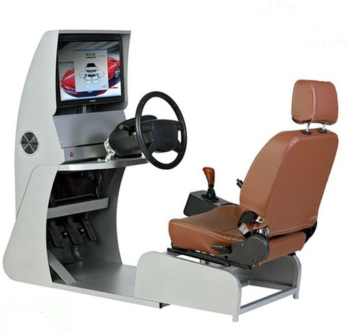

Driving simulators are very expensive to afford and cannot be easily bought by an average economic class family or person. This also applies to driving schools that have car driving simulators as a means to teach its customers. Often bought by economically heavy-earning schools investing too much on this product. Talking about cars, they are a liability and the cost of maintenance is high when compared to simulators. As we can see in amazon products that sell simulators costing from Rs.25,000 upto Rs.3,00,000 alone. Our project is to eliminate such a gap of affordability. Can be used to give simulated experience to learners before giving them an hands-on actual car for driving on a road.

**2. LITERATURE SURVEY**

We have done comprehensive study of the latest technological trends and efficient systems. We have undertaken extensive literature survey to study on Driving Simulator.A well planned literature survey has ensured availability of information for efficient system performance, technology usage, specialization and management of available resources.

Our study includes the current knowledge, findings, as well as theoretical and methodological contributions for development of Driving Simulator.. It involves concept development, which is a set of activities carried out in the system engineering to collect parameters of operational needs and develop suitable systems for implementation.The cost of making a homemade simulator takes money and also resources to set up.

This article describes a framework for generation and simulation of surrounding vehicles in a driving simulator. The proposed framework generates a traffic stream, corresponding to a given target flow and simulates realistic interactions between vehicles. The framework is based on an approach in which only a limited area around the driving simulator vehicle is simulated. framework has been validated on the number of vehicles that catch up with the driving simulator vehicle and vice versa. The agreement is good for active and passive catch-ups on rural roads and for passive catch-ups on freeways, but less good for active catch-ups on freeways. The reason for this seems to be deficiencies in the utilized lane-changing model. It has been verified that the framework is able to achieve the target flow and that there is a gain in computational time of using the outer areas. The framework has also been tested within the VTI Driving simulator III.[1-3]

Driving simulation provides a convenient and safe method for assessing driving behaviors. Many authors, however, agree that validation is a key component of any study that utilizes simulators to assess driving performance. The purpose of this study was to test driver response validity by discerning whether behavioral responses of drivers, as expressed by type and number of errors, are similar on the road and in the simulator.[4-6]

The validity of driving simulators for behavioral research is discussed[6-9]. The concept of validity is introduced and explained,[19-21] and a survey of validation studies follows, in the TNO driving simulator and others, comparing field and simulator study results.

A driving simulator can measure performance accurately and efficiently. With a real vehicle, it is far more cumbersome to obtain complete, synchronized, and accurate measurement data. It is a fundamental challenge to get an accurate recording of where a real vehicle actually is in the world. For example,in one study using an instrumented vehicle and a driving simulator, it was impossible to determine the distance between the vehicle and a stop line on the road, while in the simulator this information was readily available [10].

Measurement of lateral position is challenging as well, as this requires visible lane markers while weather conditions, reflection, and shades may affect the quality of the measurement [11]. Santos et al. [12] found that lateral position measurements of the instrumented vehicle were of marginal quality while this information was accurate in the simulator, leading the authors to conclude that “problems with field studies in an instrumented vehicle have been confirmed”.Because of the measurement capabilities of simulators, new types of behavior analyses come within reach, such as trigonometric analysis of time-to-line crossing [13] or object detection and hazard perception research using eye-tracking [14]

Simulators can be used to prepare trainees to handle unpredictable or safety-critical tasks that may be inappropriate to practice on the road, such as collision avoidance or risky driving [15]. In addition, simulators make it possible to study hazard anticipation and perception by exposing drivers to dangerous driving tasks, which is an ethically challenging endeavor in real vehicles [14]. [16] Stated that simulators “offer an opportunity to learn from mistakes in a forgiving environment” (p. 134). Allen et al. [17] made a similar case].The virtual driving simulator environment consists of a static universe, dynamic objects and interior of the driver's vehicle (Kang et al. 2004)[18].

**3. MOTIVATION**

There are several motivating reasons for me and my team to take up this amazing project, this particular project caught my attention because of 2 major reasons.

Generally speaking, the majority of the people are nervous by default. Due to this particular characteristic of a human, we tend to be even more nervous in particular new and adrenaline-pumping situations. Such situations might include ‘talking to classmates for the first time in college’ or ‘performing a show for the first time in front of an audience’. This also holds true for people who are experiencing view from the driver seat for the first time. Personally speaking from one of the team member’s experiences, the first time that he tried to drive a car, he had a near death experience. Though this particular situation happens rarely, we have all heard that people that drove for the first time in their life caused a dent to the car. Which makes the car unattractive or even makes significant damage. To avoid this, a solution had to be brought forward.

On the other hand, there are many prototypes of driving simulators which are expensive as well. The important factor in today’s world is the buzzword “economy”. Hence to improve on that factor, we as a team were motivated to create a driving simulator that would be cheap but also efficient in its purpose. This would help the driving schools and also help the customers in general but more importantly the ones that have anxiety or people with fear to do something for the first time.

There are several reasons which made us start this project but these two reasons were the most important in our perspective. I hope that our project helps the society.

**4. OBJECTIVE**

The objective of this project is to make a cheap and energy efficient prototype of a driving simulator. This particular hardware device will be such that it can be easily manufactured and produced. The overall main objective of the project will be to help the people who want to learn car driving in general, and also to those people who have the fear of driving for the first time to overcome that fear and nervousness.

**5. METHODOLOGY**

The project technology and components were elaborately discussed and the plan was finalized for the implementation. Detailed study of requirements and functioning of various existing systems and components were undertaken for defining the project methodology.

**5.1 PROBLEM DEFINITION**

In today’s market scenario, trying to own a car simulator is either expensive or considered a waste of money. Hence their usefulness is overlooked. We generally observe that many driving schools use 4 wheeler cars or an expensive simulator to teach their customers. Though this method is very effective to teach the students they are also expensive for the new learners. To reduce such costs and help people who have anxiety in learning new things we came up with this cheap and effective hardware that would provide an alternative.

**5.2 PROJECT METHODOLOGY**

The methodology of the project is to design and implement a hardware driving simulator machine that would work using python language and raspberry pi microcontroller. More importantly using the python libraries such as openCV, imutils for frame processing and XInput for key-press emulations. The validity of this project concept is required to be demonstrated by using hardware components, developing software and implementing to fabricate a working model of steering.

Whereas the potentiometer will be used as the accelerator and brake pedal which provides variable voltage by analog input. This input will be converted into digital data by ADC: MCP 3008; this digital data is then input is provided to I2C which is analysed to simulate accelerate or decelerate the car.

**5.3 PROJECT TECHNOLOGY**

Apart from the basic engineering knowledge, certain technologies covering raspberry pi, python programming, project design and development, ADC performed by(SAR: Successive Approximation Register). We have also used software python packages such as XInput and usage of openCV using a 5MP camera.

**5.4 PROJECT IMPLEMENTATION**

1. Initially we have to install the raspberry pi OS which is available from the developer's website. After booting up we will have to install a python text editor(optional).
2. Install all the necessary libraries for python such as imutils for video processing, openCV for image detection and processing and Xinput for key press emulation.
3. At this point we will have to build a structure to hold the steering wheel using cardboard for testing and as a model(prototype); for accelerator pedal and brake pedal using the wood fitted with potentiometer for each to vary voltage as a way of conversion of analog rotation to digital format. MCP3008 will be the main ADC(Analog to digital converter) that will be used for the above operation.In turn this converted digital data can be used to generate keypress for input as a means of emulation using XInput library. This model will be fitted with a spring to push the pedal back up after lifting the feet back up.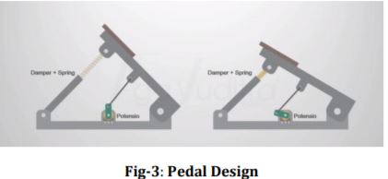
4. Coming to the operation of the steering wheel we use image processing techniques to detect how the user is turning the steering wheel and registering this using the vast openCV library. This registered value will provide keypress emulation by XInput, that will be coded and programmed for the digital car to turn during the simulation.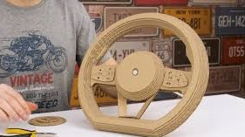
5. The final output during the demo will look like the following. The given image has exactly 1-bit(strictly left and right) values at present; this can be improved by providing 8-bit analog to digital converted inputs.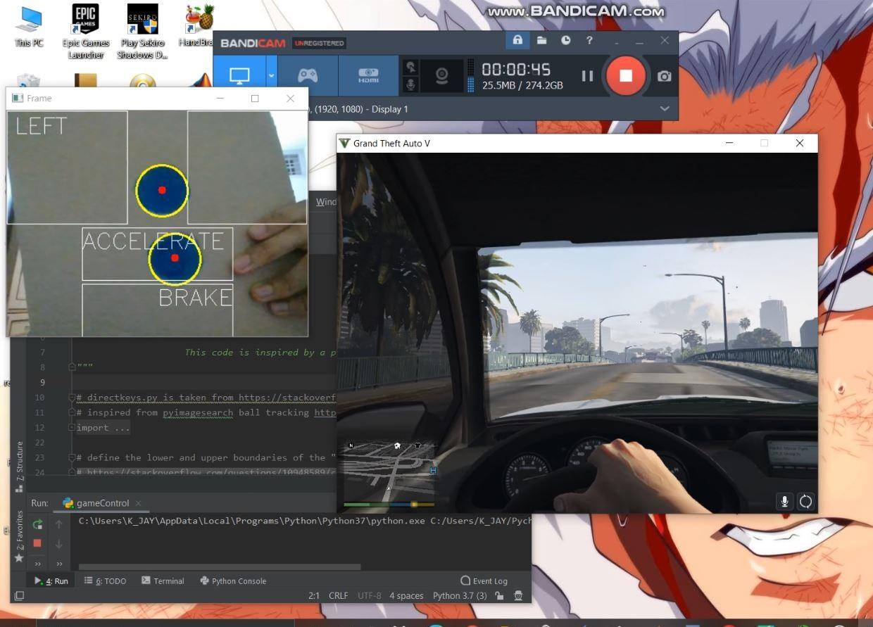

**5.5 PROJECT HARDWARE**

**5.5.1 Raspberry Pi**

Raspberry Pi is a series of small single-board computers developed in the United Kingdom by the Raspberry Pi Foundation in association with Broadcom.

Raspberry Pi is a small single board computer. By connecting peripherals like Keyboard, mouse, display to the Raspberry Pi, it will act as a mini personal computer. Raspberry Pi is popularly used for real time Image/Video Processing, IoT based applications and Robotics applications. Raspberry Pi is slower than laptop or desktop but is still a computer which can provide all the expected features or abilities, at a low power consumption.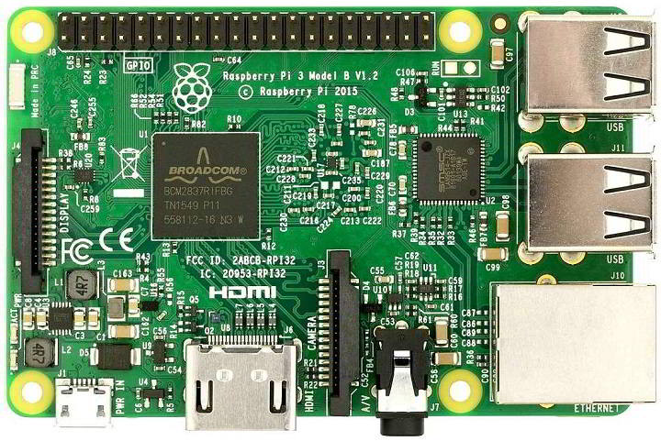

**Raspberry Pi 3 Board**

**5.5.2 5MP Camera Module**

The Pi camera module is a portable lightweight camera that supports Raspberry Pi. It communicates with Pi using the MIPI camera serial interface protocol. It is normally used in image processing, machine learning or in surveillance projects. It is commonly used in surveillance drones since the payload of the camera is very less. Apart from these modules Pi can also use normal USB webcams that are used along with computers.

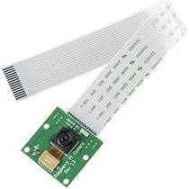

**5MP Pi Camera Module**

**5.5.3 Ethernet cable**

An Ethernet cable, sometimes referred to as a network cable, is a cord that runs from a router, modem, or network switch to your computer, giving your device access to the local area network (LAN) - in other words, giving it internet access.

The benefit of hardwiring your internet connection is that it's faster and more consistent. Without walls or other objects blocking your Wi-Fi signals, you don't have to worry about sudden drops in internet speed.

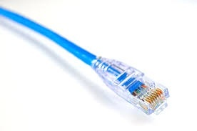

**Ethernet cable**

This cable is similar to a telephone cable except for the connector because it is wider. A telephone cable includes four pins whereas an Ethernet cable includes eight pins. For instance, if a laptop includes an Ethernet port, then the cable can be plug in to make a wired connection using a router or modem. The cable /connector of this network will make a noise once the plastic spring inserted within the port of the network so that it indicates the cable is tightly plugged in toward the socket because it must have a suitable electrical connection. These cables are available in different lengths as well as colors.

**5.6. PROJECT SOFTWARE**

**5.6.1 Python 3**

Python is an interpreted, high-level and general-purpose programming language. Python's design philosophy emphasizes code readability with its notable use of significant whitespace. Its language constructs and object-oriented approach aim to help programmers write clear, logical code for small and large-scale projects. Hence backbone for our project.

**5.6.2 Raspberry Pi OS**

**Raspberry Pi OS**[[3]](https://en.wikipedia.org/wiki/Raspberry_Pi_OS#cite_note-3) (formerly **Raspbian**) is a [Debian](https://en.wikipedia.org/wiki/Debian)-based operating system for Raspberry Pi. Since 2015 it has been officially provided by the Raspberry Pi Foundation as the primary operating system for the Raspberry Pi family of compact single-board computers.

**5.6.3 PyCharm IDE**

PyCharm is an integrated development environment (IDE) used in computer programming, specifically for the Python language.It provides code analysis, a graphical debugger, an integrated unit tester, integration with version control systems (VCSes), and supports web development with Django as well as data science with Anaconda.PyCharm is cross-platform, with Windows, macOS and Linux versions.

**5.6.4 OpenCV library**

We use OpenCV (Open Source Computer Vision Library) which is a library of programming functions mainly aimed at real-time computer vision. OpenCV is an open source computer vision and machine learning software library that makes it easy for businesses to utilize and modify the code. Using openCV and Numpy libraries of Python to control a racing game with the steering wheel. It gives you a virtual driving experience.

**5.6.5 vgamepad library**

Virtual Gamepad (vgamepad) is a small python library that emulates XBox360 and DualShock4 gamepads on your system. It enables controlling e.g. a video-game that requires analog input, directly from your python script.

Under the hood, vgamepad uses the [ViGEm](https://github.com/ViGEm) C++ framework, for which it essentially provides python bindings and a user-friendly interface. Thus far, vgamepad is compatible with Windows only.

**6. RESULT**

A car driving simulator model will be fabricated and a demo will be shown.

**7. REFERENCES**

[1] Ahmad, O. y Papeles, Y. 2001. A comprehensive microscopic autonomous driver model for use in high-fidelity driving simulation environments. In Proceedings of the 81st Annual Meeting of the Transportation Research Board. Washington, DC.

[2] Barceló, J. and Casas, J. 2002. Dynamic network simulation with AIMSUN. In Proceedings of the International Symposium on Transport Simulation. Yokohama, Japan. http://www.aimsun.com/Yokohama_revised.pdf.

[3] Blad, P. 2002. Part E: Traffic Generators. In TPMA - Model-1 final report. F. Davidsson, I. Kosonen and A. Gutowski, Eds., Centre for Traffic Research (CTR). Stockholm, Sweden.

[4] Alm, H. (1996). Driving simulators as research tools: A validation study based on the VTI driving simulator. Sweden: Swedish National Road and Transport Research Institute (VTI).

[5] Lorentzen, T., Bymes, A., & Ito, Y. (2009). VR simulation: Integrating drivers and environments. Australian Institute of Traffic Planning and Management National Conference, Adelaide, South Australia.

[6] Lorentzen, T., Kobayashi, Y., & Ito, Y. (2009a). Virtual reality driving simulation: Integrating infrastructure plans, traffic models, and driving behaviours. 15th World Congress on Intelligent Transportation Systems and Services. Stockholm, Sweden.

[7] Allen, R W. and Jex, HR (1980). Driving Simulation - Requirements, Mechanization And Application. Paper 800488, SAE, Warrendale, Pa., Feb. Allen, R W., Klein, RH.

[8] Ziedman, K. (1979). Automobile Research Simulators: A Review And New Approaches. Transportation Research Board 706, pp.9-15.

[9] Nilsson L. (1993). Behavioural Research In An Advanced Driving Simulator- Experiences Of The VTI System. VII Report 197.

[10] Roskam, A.J., Brookhuis, K.A., De Waard, D., Carsten, O.M.J., Read, L., Jamson, S., … Victor, T. (2002). HASTE Deliverable 1: Development of experimental protocol. Retrieved from

[11] Santos, J., Merat, N., Mouta, S., Brookhuis, K., De Waard, D. (2005).The interaction between driving and in-vehicle information systems: Comparison of results from laboratory, simulator and real-world studies. Transportation Research Part F 8, 135-146.

[12] Van Winsum, W., Brookhuis, K. A., De Waard, D. (2000). A comparison of different ways to approximate time-to-line crossing (TLC) during car driving. Accident Analysis and Prevention 32, 47-56.

[13] Underwood, G., Crundall, D., Chapman, P. (2011). Driving simulator validation with hazard perception. Transportation Research Part F 14, 435-446.

[14] Hoeschen, A., Verwey, W., Bekiaris, E., Knoll, C., Widl Roither, H., De Waard, D., et al. (2001)

[15] Flach, J.M., Dekker, S., Stappers, P.J. (2008). Playing twenty questions with nature (the surprise version): Reflections on the dynamics of experience. Theoretical Issues in Ergonomics Science 9, 125-154.

[16] Allen, R.W., Park, G.D., Cook, M.L., Fiorentino, D. (2007). The effect of driving-simulator fidelity on training effectiveness. Proceedings of the Driving Simulation Conference North America, Iowa City, IA.

[17] Vlakveld, W.P. (2005). The use of simulators in basic driver training. HUMANIST Workshop on the application of new technologies to driver training, Brno, Czech Republic. Retrieved from Käppler, W.D. (1993). Views on the role of simulation in driver training. Proceedings of the 12th European Annual Conference on Human Decision Making and Manual Control, Kassel, Germany, 5.12-5.17.

[18] Mohd Khalid Mokhtar and MohdShahrizalSunar “3D GRAPHIC SCENE MANAGEMENT IN DRIVING SIMULATOR,

[19] Moore, G. E. (1965).Cramming more components onto integrated circuits. Electron 38, 114-117.

[20] Generating dynamic scenarios in a driving simulator. IEEE Intelligent Systems 21, 28-32.

[21] Godley, S. T., Triggs, T.J., Fildes, B.N. (2002). Driving simulator validation for speed research. Accident Analysis and Prevention 34, 589-600.